



**BME UNIVERSITY**

**FACULTY of ELECTRICAL ENGINEERING AND INFORMATICS**

*BMEVIHIMA07– Mobile and Wireless Networks*

**MEMBERS**

E3W1OW- Muhammet ŞERAMET

1. **Definition of Wi-Fi**

**Wi-Fi** is a family of **wireless** networking technologies, based on the **IEEE 802.11** family of standards, which are commonly used for local area networking of devices and Internet access.

**1.1 How Wi-Fi Networks Work**

Wi-Fi networks have no physical wired connection between sender and receiver by using radio frequency (RF) technology -- a frequency within the electromagnetic spectrum associated with radio wave propagation. When an RF current is supplied to an antenna, an electromagnetic field is created that then is able to propagate through space.[[1]](https://www.webopedia.com/TERM/W/Wi_Fi.html)

The cornerstone of any wireless network is an access point (AP). The primary job of an access point is to broadcast a wireless signal that computers can detect and "tune" into. In order to connect to an access point and join a wireless network, computers and devices must be equipped with wireless network adapters.

**1.2 The Wi-Fi Alliance**

The Wi-Fi Alliance, the organization that owns the Wi-Fi registered trademark term specifically defines Wi-Fi as any "wireless local area network (WLAN) products that are based on the Institute of Electrical and Electronics Engineers' (IEEE) 802.11 standards."[[2]](https://www.webopedia.com/TERM/W/Wi_Fi.html)

1. **Versions of Wi-Fi**

**2.1 What is Wi-Fi 4? Wi-Fi 5? Wi-Fi 6?**

The IEEE naming scheme for the standard is a little tough to get used to, and in an effort to make it easier to understand, the Wi-Fi Alliance has come up with some simpler names.

Under its naming convention, the alliance calls 802.11ax Wi-Fi 6. 802.11ac is now Wi-Fi 5, and 802.11n is Wi-Fi 4. The idea, according to the Wi-Fi Alliance, is to make matching endpoint and router capabilities a simpler matter for the rank-and-file user of Wi-Fi technology.

* WiFi 0 = 802.11
* WiFi 1 = 802.11b
* WiFi 2 = 802.11a
* WiFi 3 = 802.11g
* WiFi 4 = 802.11n
* WiFi 5 = 802.11ac
* WiFi 6 = 802.11ax

**2.2 Older Versions Of Wi-Fi (Wi-fi 1/2/3 -- Legacy 802.11)**

A brief look at past legacy wifi generations:

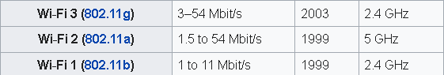[[3]](https://en.wikipedia.org/wiki/Wi-Fi#Versions)

* **802.11** (Wi-Fi 0): PHY data rates 1 Mbps to 2 Mbps with three non-overlapping 22 MHz channels in 2.4 GHz.

Approximate Range:

Indoor: 20m (66 ft)

Outdoor: 100m (330 ft)

* **802.11b** (Wi-Fi 1): PHY data rates 1 Mbps to 11 Mbps with three non-overlapping 22 MHz channels in 2.4 GHz.

Approximate Range:

Indoor: 35m (115 ft)

Outdoor: 140m (460 ft)

* **802.11a (**Wi-Fi 2**):** PHY data rates 1.5 Mbps to 54 Mbps with 12 non-overlapping 20 MHz channels in 5 GHz (36, 40, 44, 48, 52, 56, 60, 64, 149, 153, 157, 161), but some channels (52-64) had DFS restrictions. But 802.11a really never 'took off' since initial 802.11a devices worked only in the 5 GHz band (did NOT support existing 802.11b clients in the 2.4 GHz band) and were expensive (as compared to 802.11b products).

Approximate Range:

Indoor: 35m (115 ft)

Outdoor: 120m (390 ft)

* **802.11g** (Wi-Fi 3): PHY data rates 3 Mbps to 54 Mbps with three non-overlapping 20 MHz channels in 2.4 GHz (1, 6, 11). Essentially 802.11a technology in 5 GHz was moved into the 2.4 GHz band. 802.11g was highly successful. And it worked great considering that typical broadband Internet speeds were around 3 Mbps.

Approximate Range:

Indoor: 38 m (125 ft)

Outdoor: 140 m (460 ft)

**2.3 Wi-Fi 4 (802.11n) 2.4 GHz**

IEEE 802.11n was the next of the IEEE 802.11 series of wireless LAN standards after 802.11a, 802.11b, and 802.11g to enable the Wi-Fi technology keep up with the requirements of increased speed and capability.

IEEE 802.11n sought to increase the achievable speeds of Wi-Fi networks beyond that achievable using 802.11g. With increased levels of high data being transferred, often driven by the use of video, the IEEE sought to keep a step ahead of requirements and ensure that Wi-Fi was able to meet the needs of users for the coming years.

**Specifications**

[Figure-4](https://www.electronics-notes.com/articles/connectivity/wifi-ieee-802-11/802-11n.php)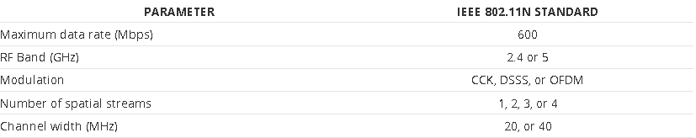

To achieve this a number of new features that have been incorporated into the IEEE 802.11n wireless LAN standard to enable the higher performance. The major innovations are summarised below:

* Changes to implementation of **OFDM**
* **Introduction of MIMO**
* MIMO power saving
* Wider channel bandwidth
* **Antenna technology**
* Reduced support for **backward compatibility** under special circumstances to improve data throughput

**Backward Compatibility Switching**

802.11n provides backward compatibility for devices in a net using earlier versions of Wi-Fi, this adds a significant overhead to any exchanges, thereby reducing the data transfer capacity. To provide the maximum data transfer speeds when all devices in the wireless network are operating on the 802.11n standard, the backwards compatibility feature can be removed.

In view of the features associated with backward compatibility, there are three modes in which an 802.11n access point can operate:

* **Legacy** (only 802.11 a, b, and g)
* **Mixed** (both 802.11 a, b, g, and n)
* **Greenfield** (only 802.11 n) - maximum performance

By implementing these modes, 802.11n is able to provide complete backward compatibility while maintaining the highest data rates. These modes have a significant impact on the physical layer, PHY and the way the signal is structured.

**Changes in OFDM Implementation**

**OFDM** is a form of signal format that uses a large number of close spaced carriers that are each modulated with low rate data stream. The close spaced signals would normally be expected to interfere with each other, but by making the signals orthogonal to each other there is no mutual interference. The data to be transmitted is shared across all the carriers and this provides resilience against selective fading from multi-path effects.

The way the OFDM has been used has been tailored to enable it to fulfil the various requirements for 802.11n.

To achieve this, two new formats are defined for the PHY Layer Convergence Protocol, PLCP, i.e. the Mixed Mode and the Green Field. These are called High Throughput, HT formats. In addition to these HT formats, there is also a legacy duplicate format. This duplicates the 20MHz legacy packet in two 20MHz halves of the overall 40MHz channel.

The signal formats are changed according to the mode in which the system is operating:

* Legacy Mode: This may occur as either a 20 MHz signal or a 40 MHz signal:
* 20 MHz: In this mode the 802.11n signal is divided into 64 sub-carriers. 4 pilot signals are inserted in sub-carriers -21, -7, 7 and 21. In the legacy mode, signal is transmitted on sub-carriers -26 to -1 and 1 to 26, with 0 being the centre carrier. In the HT modes signal is transmitted on sub-carriers -28 to -1 and 1 to 28.
* 40 MHz: For this transmission two adjacent 20MHz channels are used and in this instance the channel is divided into 128 sub-carriers. 6 pilot signals are inserted in sub-carriers -53, -25, -11, 11, 25, 53. Signal is transmitted on sub-carriers -58 to -2 and 2 to 58.

In terms of the frames that are transmitted, they conform to the legacy 802.11a/g OFDM format.

* Mixed Mode: In this 802.11n mode, packets are transmitted with a preamble compatible with the legacy 802.11a/g. The rest of the packet has a new MIMO training sequence format.
* Greenfield Mode: In the Greenfield mode, high throughput packets are transmitted without a legacy compatible part. As this form of packet does not have any legacy elements, the maximum data throughput on the wireless LAN is much higher.

**Introduction Of MIMO**

MIMO is a form of antenna technology that uses multiple antennas to enable signals travelling via different paths as a result of reflections, etc., to be separated and their capability used to improve the data throughput and / or the signal to noise ratio, thereby improving system performance.

The 802.11n standard allows for up to four spatial streams to give a significant improvement in the available data rate available as it allows a number of different data streams to be carried over the same channel.

As might be expected, the number of data streams and hence the overall data capacity is limited by the number of spatial streams that can be carried - one of the limits for this is the number of antennas that are available at either end.

To give a quick indication of the capability of a given system or radio a simple notation may be used. It is of the form: a x b : c. Where a is the maximum number of transmit antennas or RF chains at the transmitter; b is the maximum of receive antennas or receive RF chains; and c is the maximum number of data spatial streams.

The 802.11n standard allows for systems with a capability of up to 4 x 4 : 4. However common configurations that are in use include 2 x 2 : 2; 2 x 3 : 2; 3 x 2 : 2. These configurations all have the same data throughput capability and only differ by the level of diversity provided by the antennas. A further configuration of, 3 x 3 : 3 is becoming more widespread because it has a higher throughput, because of the extra data stream that is present.

**Antenna Technology**

For 802.11n, the antenna associated technologies have been significantly improved by the introduction of beam forming and diversity.

Beam forming focuses the radio signals directly along the path for the receiving antenna to improve the range and overall performance. A higher signal level and better signal to noise ratio will mean that the full use can be made of the channel.

Diversity uses the multiple antennas available and combines or selects the best subset from a larger number of antennas to obtain the optimum signal conditions. This can be achieved because there are often surplus antennas in a MIMO system. As 802.11n supports any number of antennas between one and four, it is possible that one device may have three antennas while another with which it is communicating will only have two. The supposedly surplus antenna can be used to provide diversity reception or transmission as appropriate.

**Conclusion**

The introduction of IEEE 802.11n was a major step forwards in wireless LAN technology. It enabled Wi-Fi to keep up with the rising demands required by the increasing number of Wi-Fi enabled smartphones and other electronic devices.

802.11n pioneered a number of new technologies that were carried forwards into later versions of the 802 Wi-Fi standard, and many electronic devices continued to use it for many years afterwards.

**2.4 Wi-Fi 5 (802.11ac) 5 GHz**

IEEE 802.11ac was introduced to further improve the speed of wireless LANs as well as the link speed between smartphones, Wi-Fi enabled televisions, game consoles and a host of other Wi-Fi enabled electronic devices.

IEEE 802.11ac Wi-Fi provided what was termed Very High Throughput, VHT data transfer speeds of a minimum of 1 Gbps and tops speeds of 7 Gbps.

Using speeds of this order, wireless LANs and general wireless communications would be able operate without the local area network or Wi-Fi link becoming the limiting factor.

Within IEEE 802.11ac a number of key features were introduced, and to achieve the top speeds mentions, these needed to be enabled before the very high throughput data rates could be achieved on the WLAN or wireless communications link.

**Specifications**

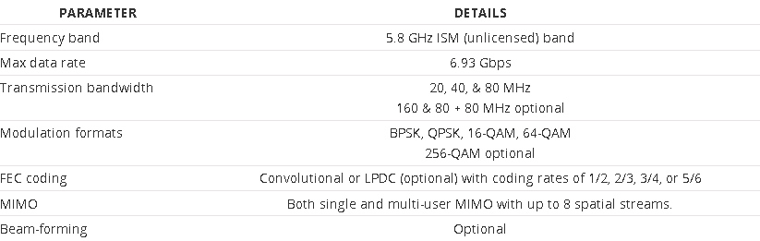

[Figure-5](https://www.electronics-notes.com/articles/connectivity/wifi-ieee-802-11/802-11ac.php)

When 802.11ac was first launched, not all the final capabilities could be included in the first products. Many products had been developed to meet the basics of the draft specification prior to its proper launch. To address this and gain clarity in the marketplace, the Wi-Fi Alliance separated the launch into two phases: Wave 1 and Wave 2.

The Wi-Fi Alliance commenced certifying Wave 1 802.11ac electronic devices, manufactured to IEEE 802.11ac Draft 3.0 from mid 2013. Then in 2016, the Alliance started to certify Wave 2 electronic devices . By this time, additional features including MU-MIMO, 160 MHz channel width support, support for more 5 GHz channels, and four spatial streams using four antennas (compared to three in Wave 1 and 802.11n).

**OFDM**

The IEEE 802.11ac standard utilises OFDM that has been very successfully used in previous forms of 802.11. The use of OFDM is particularly applicable to wideband data transmission as it combats some of the problems with selective fading.

**MIMO and MU-MIMO**

In order to achieve the required spectral usage figures to attain the data throughput within the available space, the spectral usage figure of 7.5 bps/Hz is required. To achieve this, MIMO is required, and in the case of IEEE 802.11ac Wi-Fi, a form known as Multi-User MIMO, or MU MIMO is implemented.

**Physical layer frame**

As with other 802.11 standards, there is a Physical Layer Convergence Protocol, PLCP and this defines a PLCP Protocol Data Unit, PPDU. For 802.11ac, this has been defined to be backward compatible with 802.11a and 802.11n which may also use the 5.8 GHz unlicensed ISM band.

There are various fields within the frame structure:

* ***L-STF***: This short training field is two symbols in length and it is transmitted for backwards compatibility with previous versions of 802.11. The field is duplicated over each 20 MHz sub-band with phase rotation. The subcarriers are rotated by 90° or 180° in some sub-bands to reduce the peak to average power ratio.
* ***L-LTF:*** This is a legacy long training field, and is two symbols long. It has many of the same properties as the L-STF including the transmission criteria, being transmitted in sub-bands and those of phase rotation.
* ***L-SIG:*** This field is one symbol long and it is transmitted in BPSK. Like the L-STF and L-LTF it is a legacy field.
* ***VHT-SIG-A:*** This is an 802.11ac field and consists of one symbol transmitted in BPSK and a second in QBPSK, i.e. BPSK rotated by 90°. This mode of transmission enables auto-detection of a VHT transmission. The field contains information to enable the receiver to correctly interpret the later data packets. Information including he bandwidth, number of MIMO streams, STBC used, guard interval, BCC or LDPC coding, MCS, and beam-forming information.
* ***VHT-STF - VHT Short Training Field :*** This 802.11ac field is one symbol long and is used to improve the gain control estimation for MIMO operation.
* ***VHT-LTF - VHT Long Training Field:*** The long training fields may include 1, 2, 4, 6, or 8 VHT-LTFs. The mapping matrix for 1, 2, or 4 VHT-LTFs is the same as in 802.11n whereas the 6 and 8 VHT-LTF combinations have been added for 802.11ac.
* ***VHT-SIG-B:*** This field details payload data including the length of data and modulation coding scheme for the multi-user mode. Bits are repeated for each 20 MHz sub-band

**Conclusion**

When IEEE 802.11ac came onto the market, it was quickly adopted, although testing presented some interesting challenges in view of the use of MIMO, OFDM and its other features.

After 802.11ac was introduced, it quickly became the “norm” for wireless LANs as it was able to provide very high throughput transfers of data.

**2.5 Wi-Fi 6 (802.11ax) 5 GHz**

IEEE 802.11ax also known as Wi-Fi 6 is a new standard in the IEEE 802.11 series. It has been designed to provide some significant improvements over 802.11ac, especially in terms of **deployment in dense areas**, **spectral efficiency** and **user access**.

In view of this, IEEE 802.11ax will improve the use is seen as the successor to 802.11ac. The new 802.11ax is still in its early stages of development, but it is anticipated that it will provide up to four times the speed of 11ac.

Another of the key issues that 802.11ax aims to resolve is that of mutual interference between different access points. In some densely covered areas this is significantly slowing down the networks. Solving this issue rather than just providing bearers for faster data rates will have a greater effect on real throughput.

Comparatively few details have emerged yet about the actual specification, and the technology for IEEE 802.11ax, but some details have emerged.

**Specifications**

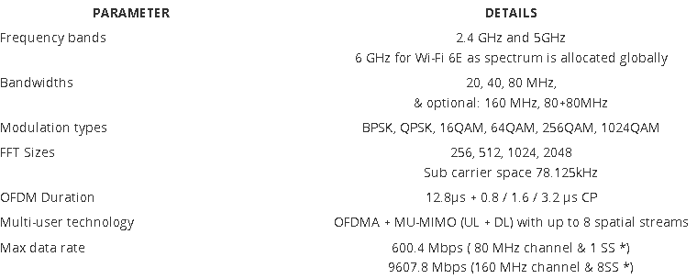

[Figure-6](https://www.electronics-notes.com/articles/connectivity/wifi-ieee-802-11/802-11ax.php)

**Orthogonal Frequency Division Multiple Access, OFDMA**

**OFDM** is a form of signal format that uses a large number of close spaced carriers that are each modulated with low rate data stream. The close spaced signals would normally be expected to interfere with each other, but by making the signals orthogonal to each other there is no mutual interference. The data to be transmitted is shared across all the carriers and this provides resilience against selective fading from multi-path effects.

IEEE 802.11ax, Wi-Fi 6 uses OFDMA, a technology which has been widely used in both the 4G and 5G mobile telecommunications systems.

The basic technology is based upon OFDM, orthogonal frequency division multiplex, where the data speed is slowed down to overcome reflections and multi-path propagation by spreading it over a number of very close spaced low data rate channels. This makes very good use of the available spectrum.

The use of OFDMA with 802.11ax increases the capacity of the system by segmenting the channels into smaller sub-channels that overlap in frequency. Previous generations of Wi-Fi would wait until there was an available slot for the whole channel, but 802.11ax enables different devices to use sections of the channel, i.e. a number of the individual OFDM carriers and this enables simultaneous parallel transmissions to occur. In turn this makes the Wi-Fi network become more efficient because devices do not have to compete with each other for a time slot for the whole channel.

A further advantage of using OFDMA is that the Wi-Fi routers can dynamically adjust the power for each device, giving more power to more distant devices and less to those closer in.

In the uplink the 802.11ax router can group transmissions from multiple devices together and this can provide a sixfold increase in speed over existing networks.

The use of OFDMA in both uplink and downlink considerably improves the performance of the the WLAN for addressing multiple devices. With many more connected devices being used for remote control, etc around the home and office, these capabilities are needed.

**Target Wake Time**

One of the issues with the use of Wi-Fi on mobile devices is that it can be a significant drain on the battery. To help overcome this issue, 802.11ax implements a feature called Target Wake Time. This allows the Wi-Fi radio in battery powered devices to enter a sleep mode when they are not exchanging data.

Using this technique, the 802.11ax, Wi-Fi 6 routers and devices can negotiate sleep cycles dependent upon the traffic and in this way they wake when it is their turn to communicate with the router. In this way, significant savings in power consumption can be made. In some circumstances the battery drain can be reduced by a factor of seven.

**Conclusion**

IEEE 802.11ax Wi-Fi 6 is a major enhancement for Wi-Fi technology. Although it will provide improvements for low usage applications, it will give significant improvements in dense areas where there are many users and Wi-Fi access points. With the release of additional spectrum at 6GHz, this will give further enhancements as the additional bandwidth will provide more capacity.